TODO

TODO:: I uploaded everything to the github repo. Last time we got everything running for regression. For the incoming week, you can get yourself familiar with the code, the entry point is "nnknn_sample_regression.ipynb", and you can try trace it around and see how it uses everything else

TODO:: The next task would be to run it once with your own machine.

TODO:: After that, we will try clean up the code and see if the classificaiton is still good. We will revisit the classification code "nnknn_sample_classification.ipynb"

TODO:: Learn about Reinforcement Learning, and the reinforcement Learning code from Great/Mereck

Related work found by ChatGP
📌 Modern Links
- Episodic Control (DeepMind, Blundell et al. 2016):
Stores episodes in memory, retrieves nearest neighbors for fast Q estimates. This is basically a modern kNN-RL.
- Nearest-Neighbor Q-Learning (NNQL):
Combines Q-learning with non-parametric nearest-neighbor regression.
- Proto-Value Functions: Using similarities between states to shape value functions.

👉 In short: yes — people have used CBR and kNN in RL both in early work (instance-based RL, lazy Q-learning) and in modern work (episodic control, memory-augment

Need to have a working version of DQN to swap in my nnknn for. Think about how the swap in would work. Do I swap in the NNkNN into the target network or the policy network or both of DQN?

DOING

Human-in-the-Loop Feature Selection | Proceedings of the AAAI Conference on Artificial Intelligence

Relative Age Estimation Using Face Images
Relative Age Estimation Using Face Images

Asynchronous Methods for Deep Reinforcement Learning

A3C
Another RL model that competes with DQN.

CBR for State Value Function Approximation in Reinforcement Learning
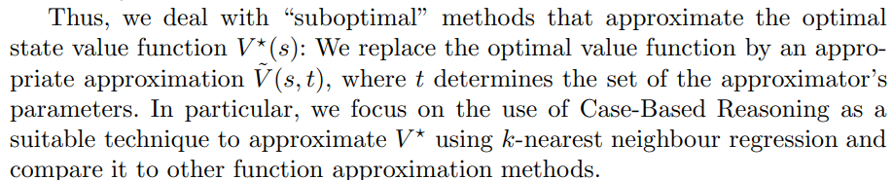
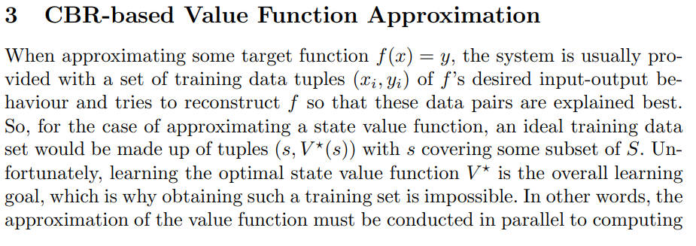
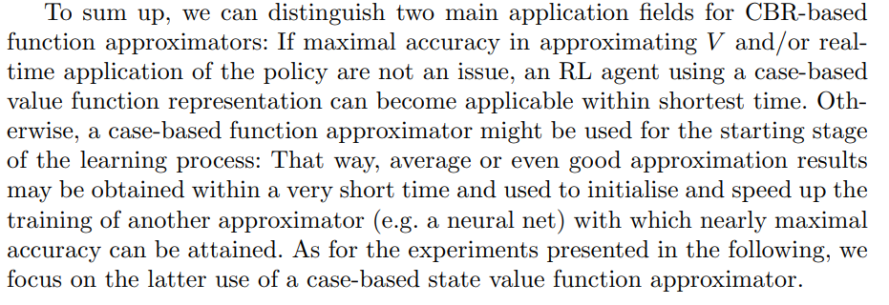
This is very interesting in two ways. (1) They also believe, like others in Neural Episodic Control, that CBR learns faster. (2) it actually coincides with my idea of the two nets, policy net and target net, where the policy net is trying to learn from the target net.
They compared their work with knn and neural net (not DQN, DQN was not out then)
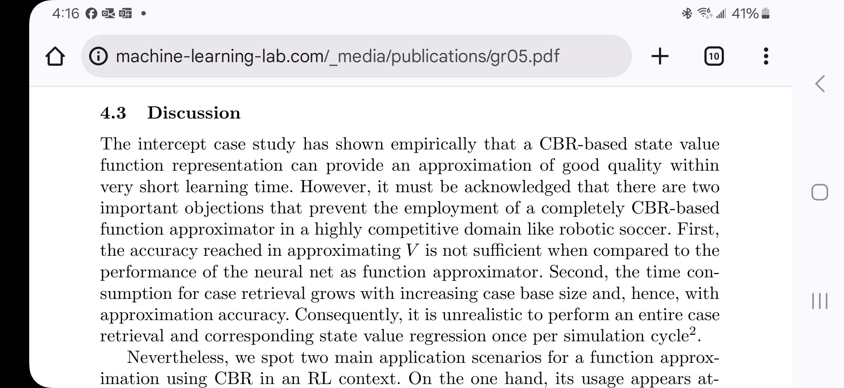
DOING

Hippocampal Contributions to Control: The Third Way

Neural Episodic Control

Replay in Deep Learning: Current Approaches and Missing Biological Elements | MIT Press Journals & Magazine | IEEE Xplore

Predictive representations can link model-based reinforcement learning to model-free mechanisms

Retrieval-augmented reinforcement learning
This title seems very relevant

Episodic memory deep q-networks

Offline reinforcement learning with value-based episodic memory

Proximal Policy Optimization

[2501.09858] From Explainability to Interpretability: Interpretable Policies in Reinforcement Learning Via Model Explaned deep RL). What your NN-kNN does is unify these ideas with a trainable, end-to-end neural network structure, making it more scalable and interpretable.

ation

DONE

1/2/2025

What to do next (in the order I’d test)

2) Force retrieval to become good before letting adaptation help (best fix)
Do a two-stage schedule:
Stage R (retrieval pretrain): freeze adapter, train feature extractor + retrieval params to minimize pre-adaptation loss.
Stage A: unfreeze adapter and train full model, but keep a small retrieval loss term.
Conceptually:
L=Lfinal+λ Lpre-adaptL = L_{\text{final}} + \lambda \, L_{\text{pre-adapt}}L=Lfinal​+λLpre-adapt​
with λ like 0.1–1.0 (tune).
Practical version:
- Epochs 0–100: adapter OFF / frozen
- Epochs 100+: adapter ON, and keep auxiliary retrieval loss

3) Don’t let the adapter overshadow retrieval (capacity + regularization)
Try one or more:
- shrink adapter hidden size / layers
- add penalty on adapter magnitude (e.g., L2 on Δy or Δz)
- add a residual scale that ramps from 0 → 1 over epochs (adapter contribution gradually allowed)

4) Make retrieval scoring closer to true KNN (important)
For a clean test, temporarily set your case scores to something monotonic like:
- z = -distances (or z = bias - distances, without sigmoid)
then softmax(z / tau).
This is a great diagnostic: if pre-adapt RMSE improves a lot, your current “sigmoid(bias-distance)*weight” scoring is the culprit.

5) Pretrain the embedding (optional but often stabilizes)
Pretrain post_mlp as a normal MLP regressor (baseline), then use its penultimate layer as the embedding init. That makes retrieval start from a meaningful geometry instead of random.

Here is why your "post_mlp" feature extractor likely failed and how to fix it.

1. The "Sparsemax Trap" (Critical)
You are using "case_normalizer": "sparsemax" (or entmax). This is dangerous when learning a feature extractor from scratch.
- The Mechanism: Sparsemax projects low-relevance scores to exactly zero.
- The Problem: At epoch 0, your feature extractor (post_mlp) is random. The "true" neighbors might be far away in this random space. Sparsemax assigns them 0 weight.
- The Consequence: Gradients cannot flow back to the feature extractor to "pull" those useful neighbors closer. The model gets stuck using random, suboptimal neighbors that happened to be close at initialization.
- Fix: Warm-up with Softmax. Force "case_normalizer": "softmax" for the first 50-100 epochs (or permanently for a test). Softmax assigns non-zero gradients to all cases, allowing the feature extractor to learn which cases should be close.

2. The Learning Rate Mismatch
In your config (Cell 267), you have:
Python
"feature_extractor_lr": 1e-4,
"case_net_lr": 1e-5, # <--- VERY LOW

- The Trap: If you use the internal "post_mlp_enabled": True, its parameters usually live inside the main model (not the separate feature_extractor module). This means they likely inherit case_net_lr.
- The Reality: An MLP typically needs a learning rate of 1e-3 (as used in your Baseline 3) to converge. You are training it at 1e-5. It is barely moving.
- Fix: Ensure the parameters of your post_mlp are grouped with feature_extractor_lr (or increase case_net_lr to 1e-3).

3. The "Locality Loss" Conflict
You are enforcing Locality Regularization ($\mathcal{L}_{ld}$) right from the start.
- The Conflict: You are punishing the model for retrieving neighbors that have different $y$ values. But at the start, the feature extractor hasn't learned the manifold yet!
- The Result: The model might "cheat" by learning a degenerate feature space where only cases with identical $y$ are close, ignoring $x$ entirely. This minimizes training loss but destroys generalization (high test error).
- Fix: Anneal the Locality Loss. Start with $\lambda_{ld} = 0$. Let the model learn a good predictive feature space first (minimize MSE). Then, slowly ramp up $\lambda_{ld}$ to enforce interpretability constraints on that space.

4. The "Silver Bullet": Pre-train the Extractor
The most robust way to beat the MLP baseline is to become the MLP baseline first.
- Train your Baseline 3 MLP (which gets 0.54 RMSE).
- Initialize your post_mlp (or feature_extractor) with the weights from that pre-trained MLP (minus the last layer).
- Freeze it (or use a very low LR) and train only the NN-kNN weights/biases initially.
- Fine-tune everything end-to-end.
Why this works: The NN-kNN starts with a manifold where Euclidean distance already works for the task. It then just needs to refine the local averaging to handle the edge cases. This guarantees you perform at least as well as the MLP, plus the interpretability benefits.

12/30/2025
Quick journal note — BodyFat regression (NN-kNN)
What I tried:
- Compared NN-kNN vs baseline MLP on BodyFat (242 rows, 10 features; 80/20 split = 193 train / 49 val).
- Noticed training-loss “instability”; confirmed a big part was last-mini-batch noise (small dataset + batching). Added/considered drop_last=True and focusing on epoch-averaged losses rather than last-batch components.
- Swept multiple configs (normalizer choices, tau, locality weights). Result: sparsemax + locality regularization generally improved performance relative to softmax and relative to “no locality”, but still failed to match the MLP.
- Added a built-in tabular feature extractor (post-MLP projector like X→32→16 with ReLU, dropout). Fixed a device mismatch bug (feature extractor on CPU while tensors on CUDA). Even after it ran correctly, performance didn’t improve meaningfully.
- Revisited feature-weight projection: concluded hard in-place normalization/projection can create train–eval mismatch. Switched to a display-only normalization function for logging instead of modifying weights.
Bottom line:
- Even with sparsemax + locality and a small feature extractor, NN-kNN still underperforms the MLP on BodyFat.
- Next step: implement/test a hybrid model (global MLP prediction + NN-kNN residual correction) to preserve explanations while matching MLP-level predictive strength.

12/14/2025
We also experimented with constraining glocal feature weights to lie on a simplex (non-negative and normalized), which yields a cleaner metric interpretation. However, in our current tasks this constraint slightly degraded predictive performance, so we report results with the unconstrained leaky-ReLU parameterization and leave stricter metric constraints as future work.
My experiment with normalizing glocal feature weights and glocal set weights have failed so far. Losing degrees of freedom leads to less accuracy.

12/9/2025 meeting notes
Here is some plan/notes I have before our meeting on Tuesday. No need to reply this long email but feel free to skim before our meeting:

- Conference goals:
IJCAI conference timeline
Abstract submission deadline: January 12, 2026
Author information and Full paper submission deadline (including Appendix and resubmission information): January 19, 2026
Summary reject notification: March 4, 2026

ICCBR conference timeline
- Paper Submission Deadline: March 20, 2026
- Paper Acceptance/Rejection Notification Deadline: April 28, 2026
I am going to aim for IJCAI. I am confident that this paper will be a good enough work. But if somehow IJCAI rejected us in the first stage, we can still submit to ICCBR.

2. Current paper overall design:
This paper is an extension of our previous NN-kNN. The paper's contribution will be novel in following:
- We will show regression poses a unique challenge for NN-kNN that is not present in classification: NN-kNN can potentially learn to interpolate with not good neighbors. (This circles back to our discussion about what is a good neighbor, but I think it's safe to assume the CBR principle: similar problems have similar solutions. We want to explain by case, or by finding a case with a similar problem and similar solution.)
Note:: this needs to rephrase in terms of broader ML community. people don’t know nn-knn.
- We address the challenge above by sparsemax/entmax + a retrieval loss that encourages locality (or the retrieval of good neighbors).
- We combine NN-kNN with NN-CDH. In CBR perspective, NN-kNN is for retrieval and NN-CDH is for adaptation. NN-CDH is from our previous project so itself is not the novel contribution here. The combination is useful because everything is end-to-end now: retrieval and adaptation train in harmony (relate to our other paper on Alternating Optimization (AO) of retrieval + adaptation).
- Ideally, NN-kNN retrieve a good neighbor (guided by retrieval loss), and NN-CDH does the last mile push (guided by adaptation loss, or MSE loss of the final prediction).
One counter argument might be, NN-CDH is a black-box neural network learning from case difference heuristic (CDH) rules. It is not as explainable as the rest of the model. To that my counter involves two points:
  - Last bit of neural adaptation is OK. The case is already retrieved and the case is still a good explanation. Our retrieval loss will encourage retrieved case to be close to target prediction so the adaptation needed is minimal. We can sacrifice some explainablity for accuracy.
  - If we want an explainable adaptation. We could potentially build NN-CDH with another NN-kNN. Essentially, a CDH built from NN-kNN. The cases will be adaptation rules. In other words, the input and the cases of the NN-kNN will be problem differences, and the output will be solution differences. Everything else will just be like regular NN-kNN. Honestly, this is a paper by itself. We can choose to (1) not do it but mentioning it (2) do it here (3) do it in a seperate paper for ICCBR.
    - Note: Anywhere a neural network is used, could potentially be replaced with a NN-kNN, this is a ramification of NN-kNN regression, because now we can output either classification labels or numerical numbers.

3. Experiments:
  - For NN community: We will compare NN-kNN + NN-CDH (our model) with other regression model baselines on multiple standard regression data sets: weighted k-NN for regression, MLP, MLKR, gradient boosted tree (last two suggested by ChatGPT). We will compare their accuracy and their case explainability (how close the top case(s) are to the target prediction).
  - For CBR community: We will compare our model with the original NN-CDH on the data sets we tested on in the NN-CDH paper. A direct comparison with NN-CDH. We can also compare our model with our AO paper, which uses a siamese network for retrieval and a NN-CDH for adaptation.
  - Explanation by activated case:k-NN: would retrieve some cases,
MLP: can use the penultimate layer as features to retrieve cases.
more general audience than the original NN-kNN.
We can add a similarity measure loss if we have an explainable similarity that we want to conform to. (number of features
Note:: The similarity measure learned by our model does not necessarily apply to knn or MLP, it would be unfair to use our retrieval loss/similarity on them. However, if we do this on the artificial dataset, then yes. We can retrieve the top k cases, for every method, and calculates the average distance of the top k cases to the query, the distance will be waited by the real feature weights.
  - Explanation by features: Some data sets where we demonstrate the learned weights aligns with human intuition, the depression data sets. I also have a self-reported mental health dataset from covid time. Haven't tested on that yet.
Additional. Multiple feature sets having effect: a data sets with two lines, ab vs cd. NNkNN should learn two sets of glocal weights
  - Explanation by case weights and biases: ablation study. case weights and biases, we can try ablation study. what happens if we keep only the cases with high weights. What happens if we keep only the cases with low weights. Can do this on all datasets/all baselines after the data set has been pruned.
  - Feature Manual Tuning: One thing that I haven't shown in our meetings, but did before personally, was the manual tuning of feature weights. This is only possible in NN-kNN but not in other neural nets because we clearly know what the feature weights stand for and we can intervene.
How to evaluate? We can create a dataset, where feature a is important, but not allowed to train at the beginning. Then after training, we can do a thing, modify weights for feature (a) and then do one of two things :(1) allow retraining (2) don’t allow retraining (requires good setting). and show the model’s performance after the manual fine tuning.

  - Reinforcement Learning: This is an extension. To show that NN-kNN for regression can go beyond simple regression and be used as if it is explainable Deep-Q net (DQN). DQN is used to estimate the reward of states in RL.

I am thinking of another generated regression problem, say y = w1 * x1 + w2* x2 + w3 * x3. Let's say the real weights are w1 = 2, w1=1, and w3=0. We can randomly generate bunch of X values and calculate their corresponding true Y. So we can calculate the performance gain quantitatively. This will be measured by retrieval loss (how good the retrieved cases are) and adaptation loss (how good the final prediction is).

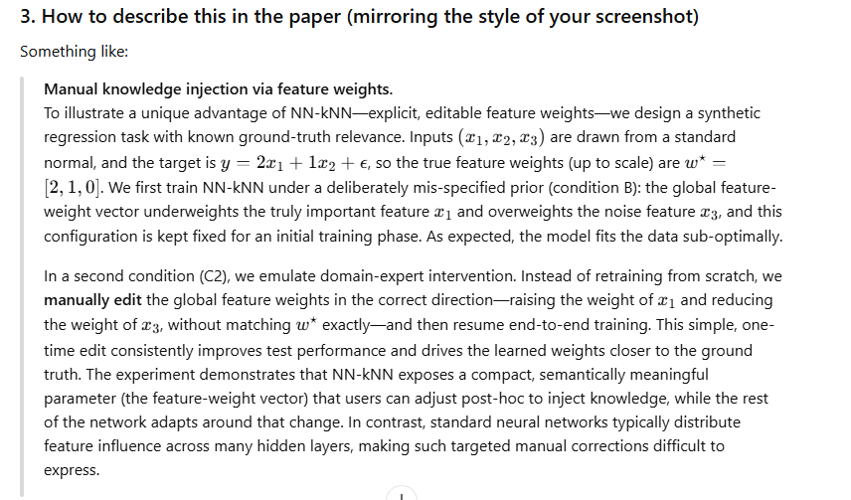

12/5/2025
NN-CDH is not explainable. Which is OK, as long as the retrieval is good and the adaptation is minor yet toward the correct label, we can sacrifice some explainablity for accuracy.
On another note, the adaptation part could potentially be also explainable. If we swap NN-CDH with a NNkNN-CDH, essentially, a CDH built from NN-kNN. The cases will be adaptation rules. In other words, the input and the cases of the NN-kNN will be problem differences, and the output will be solution differences. Everything else will just be like regular NN-kNN.
Note: Anywhere a neural network is used, could potentially be replaced with a NN-kNN, this is a ramification of NN-kNN regression, because now we can output either classification labels or numerical numbers.

12/1/2025
Experimented on the depression dataset. I found out that with NN-CDH turned on, the nn-knn itself is pretty bad. As a result, the whole model actually produces worse error than baselines (knn and neural network).
If I turned NN-CDH off, the NN-kNN perform just fine. Outperform both baselines, and finds some interesting features.
Configuration
cfg = {
**default_args,
"task_type": "regression",
"softmax_over_cases": True, # model enforces True in regression; kept explicit for clarity
"tau": 1.0, # attention sharpness over cases, lower -> sharper
"case_normalizer": "sparsemax", # 'softmax' | 'sparsemax' | 'entmax15'

#for locality regularization in regression
"regression_locality": True, # Whether to use locality regularization in regression training
"lambda_base": 1.0,
"lambda_kl": 0.0, # weight for KL(p||w) attention-to-label proximity (regression only)
"locality_alpha" : 2.0, # exponent for distance in locality regularization
"lambda_expdist": 0.3, #1.0, weight for expected distance loss (regression only)
"lambda_balance": 0.3, # weight for signed-bias regularizer (regression only)
"lambda_cover": 0.0, #0.5, weight for coverage loss (regression
"lambda_pair": 0.0, #0.5, weight for pos>neg pairwise hinge (regression only)
"lambda_ent": 5e-4, # 0.0, #1e-3, tiny entropy penalty (encourages sparse attention tails)
"eps_sigma_multiplier": 0.1, #0.2,0.4 multiplier for sigma_y to define "close" and "far" in pairwise loss
"pairwise_margin": 0.05, # required gap: w_pos - w_neg >= margin

"pre_topk_mask": False, # enable the pre-normalization K-sparsification, if turned on, this influences nn-cdh to only adapt to top_k neighbors
"top_k": 20, # K for Neighbor Agreement / nDCG in validation and also for explanation mode

"glocal_fw_set_num": 1,
"neg_weight_flag": False, # regression should NOT use negative class weights
"sampling_cases_flag": False, # use all cases for stable regression
"case_activation_by_top_k_average": True, # use percentile-based bias finder
"top_k_for_default_case_activation": 10, #mark.
"case_activation_default_percentage": 0.1,
"training_epochs": 800,
"batch_size": 256,
"feature_extractor_lr": 1e-4, #1e-4,1e-3,
"glocal_weightor_lr": 1e-3, #influence feature weights and glocal weights
"case_net_lr": 1e-4, #1e-4,1e-3,
"checkpoint_path": "nnknn_regression_best.pth",
"patience": 40,

"nn_cdh_pretrain": False, # Whether to pretrain nn_cdh adapter
"use_nn_cdh": False,

"explanation_mode": True
}

# No feature extractor for tabular demo
feature_extractor = None

Top important features
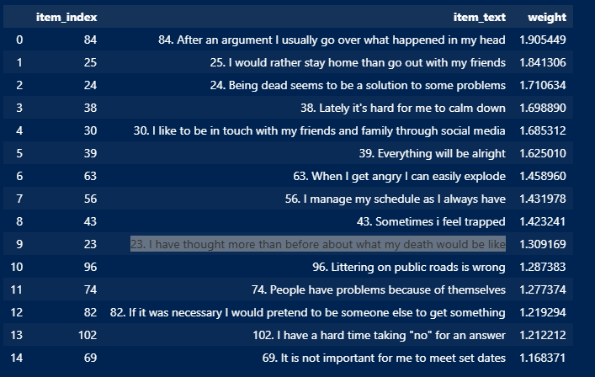
least important features
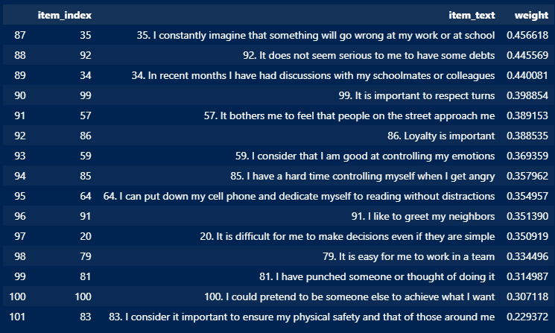
This basically aligns with what we thought.

Discussion: I believe this is because of the nature of the data set. Unlike the artificial one where there is a wide span of y and similar y share mostly similar x. Here there are only 5 possible y values, and similar y could have very different x. When NN-CDH is turned on, it learns some big adaptation rules, making NN-kNN useless in terms of accuracy (because NN-CDH will adapt), and NN-kNN is ill-trained in the process.
In other words, adaptation is only needed if good neighbors are hard to find. In this case, good neighbor is easy to find.

12/2/2025
I forgot to put this experiment result log here, so here I make up for it.
This is a good result for the artificial regression data set
# --- Choose one synthetic dataset ---

N = 3000 # N = 3000
D = 5
torch.manual_seed(42)

# Linear with noise (default)
X = torch.randn(N, D)
true_w = torch.tensor([2.5, -1.7, 0.0, 0.9, 3.2]).view(-1, 1)
rand_scale = 1.0 #1.0 # 0.5
y = X @ true_w + rand_scale*torch.randn(N, 1) # shape [N,1]

# # Nonlinear (sine) with noise — comment out the linear block above and use this instead
# N = 3000
# X = torch.linspace(-3.0, 3.0, N).unsqueeze(1)
# y = torch.sin(2 * X) + 0.2*torch.randn_like(X)

print(X.shape, y.shape)

Notice that the rand_scale is 1.0

The successful config
cfg = {
**default_args,
"task_type": "regression",
"softmax_over_cases": True, # model enforces True in regression; kept explicit for clarity
"tau": 1.0, # attention sharpness over cases, lower -> sharper
"case_normalizer": "sparsemax", # 'softmax' | 'sparsemax' | 'entmax15'

#for locality regularization in regression
"regression_locality": True, # Whether to use locality regularization in regression training
"lambda_base": 1.0,
"lambda_kl": 0.0, # weight for KL(p||w) attention-to-label proximity (regression only)
"locality_alpha" : 2.0, # exponent for distance in locality regularization
"lambda_expdist": 0.3, #1.0, weight for expected distance loss (regression only)
"lambda_balance": 0.3, # weight for signed-bias regularizer (regression only)
"lambda_cover": 0.0, #0.5, weight for coverage loss (regression
"lambda_pair": 0.0, #0.5, weight for pos>neg pairwise hinge (regression only)
"lambda_ent": 5e-4, # 0.0, #1e-3, tiny entropy penalty (encourages sparse attention tails)
"eps_sigma_multiplier": 0.1, #0.2,0.4 multiplier for sigma_y to define "close" and "far" in pairwise loss
"pairwise_margin": 0.05, # required gap: w_pos - w_neg >= margin

"pre_topk_mask": False, # enable the pre-normalization K-sparsification, if turned on, this influences nn-cdh to only adapt to top_k neighbors
"top_k": 20, # K for Neighbor Agreement / nDCG in validation and also for explanation mode

"glocal_fw_set_num": 1,
"neg_weight_flag": False, # regression should NOT use negative class weights
"sampling_cases_flag": False, # use all cases for stable regression
"case_activation_by_top_k_average": True, # use percentile-based bias finder
"top_k_for_default_case_activation": 10, #mark.
"case_activation_default_percentage": 0.1,
"training_epochs": 800,
"batch_size": 256,
"feature_extractor_lr": 1e-4, #1e-4,1e-3,
"glocal_weightor_lr": 1e-3, #influence feature weights and glocal weights
"case_net_lr": 1e-4, #1e-4,1e-3,
"checkpoint_path": "nnknn_regression_best.pth",
"patience": 40,

"nn_cdh_pretrain": True, # Whether to pretrain nn_cdh adapter
"use_nn_cdh": True,

"explanation_mode": True
}

# No feature extractor for tabular demo
feature_extractor = None
Before training starts
Training started for training_epochs epochs with batch size 256
Training loss components:
base: 0.1935 | locality_loss: 0.2373 | kl: 0.0000 | expdist: 0.1718 | cover: 0.0000 | pairwise: 0.0000 | entropy: 1.8270 | eps_used: 0.0998
Validation loss components:
base: 0.1404 | locality_loss: 0.2240 | kl: 0.0000 | expdist: 0.1575 | cover: 0.0000 | pairwise: 0.0000 | entropy: 1.7343 | eps_used: 0.0998
After training
Training loss components:
base: 0.0480 | locality_loss: 0.1226 | kl: 0.0000 | expdist: 0.0753 | cover: 0.0000 | pairwise: 0.0000 | entropy: 2.2991 | eps_used: 0.0998
Validation loss components:
base: 0.0484 | locality_loss: 0.1511 | kl: 0.0000 | expdist: 0.0981 | cover: 0.0000 | pairwise: 0.0000 | entropy: 2.2810 | eps_used: 0.0998
Epoch 149 - Val R²: 0.9465 | Reg Val Loss: 0.0990
Neighbor metrics | WLD: 0.3077 | NA@20: 0.151 | nDCG: 0.644
No improv. Best Reg Val Loss so far: 0.0981 (epoch 108)
Patience exceeded. Restoring best model.
Training completed. Best Acc or R2: 0.9466606400827379
Final global feature weights: Parameter containing:
tensor([[0.3022, 0.1914, 0.0153, 0.1037, 0.3684]], device='cuda:0',
requires_grad=True)
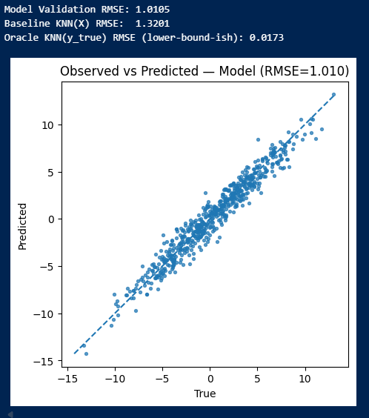
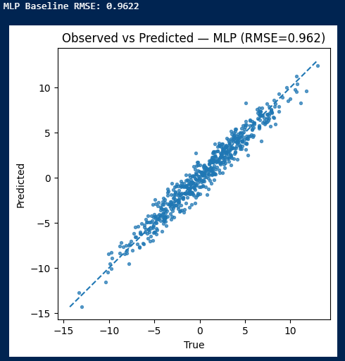
I also tried turning off the pretrain_cdh
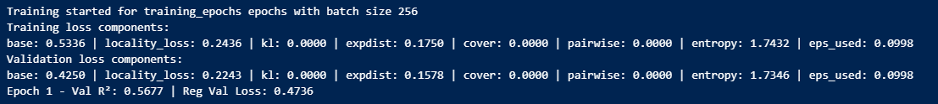
An obvious first epoch change. Because NN-CDH is not helping anymore at the beginning.
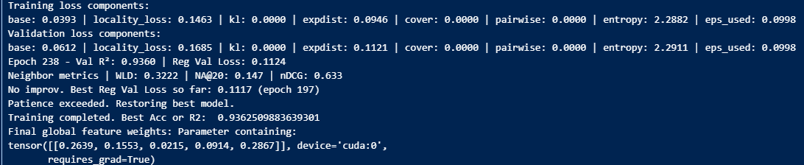
After training, this is slightly worse than with NN-CDH pretraining turned on.
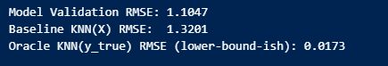

11/19/2025
As of now, we are approaching baseline NN but NN-kNN failed to surpass it. I suspect we need adaptation in regression after all. Here is the reason: for classification, if you retrieve similar cases, very likely it is the same class label. However, for regression, very likely the similar cases are off. This is especially true for the two ends. You will likely be missing data from the two ends and the model will interpolate with data in the center, dragging the predicted label to the center.
Ideally, the model learn a similarity metric that retrieves cases on both sides of the true label and learn to balance them with correct activations and weights. Problem is that, the activation values are absolute values.
See this example
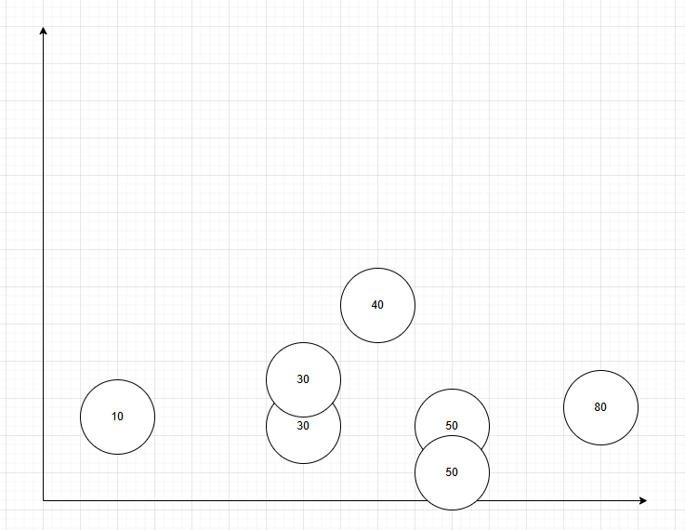
For the label 40, case 30 are the same distance away from the true label as case 50. If we activate 2 case 30, it is the same as activating 1 case 30 and 1 case 50, in terms of locality loss. So locality loss does encourage good neighbors, but not which sides the good neighbors are on.
On the other hand, the basic MSE loss does encourage good accuracy and theoretically, a perfect MSE + a locality loss will force cases to be on both sides to get a balanced out yet good prediction. But we haven’t seen that effect. My suspect is that we won’t be achieving a perfect MSE anyway and there is too much for the two losses to learn.

One possible solution is

10/25/2025

R2
tau | softmax | sparsemax | entmax15
2.0
1.0
0.2
0.05

validation error
tau | softmax | sparsemax | entmax15
2.0
1.0
0.2
0.05

error of the nearest neighbor
tau | softmax | sparsemax | entmax15
2.0
1.0
0.2
0.05

10/23/2025
Discussed with Brook Bowers. He point out something interesting:
because the model right now is doing interpolation, it will badly fit with the two ends of the data, which is shown in the results. This is because at the end of the data there is nothing else beyond to interpolate with.

10/22/2025
High tau value will activate too many cases. The training process will learn slowly and the learned model will not be accurate.
For example, when tau=2.5
[Epoch 500/500] - Loss: 3.3686
Epoch 500 - Validation R^2 Score: 0.7882 (1 is best)
Epoch 500 - Validation Loss: 3.9147
New best loss 3.9147 - Model saved.
Training completed. Best Acc or R2: 0.7881936414937856
Final global feature weights: Parameter containing:
tensor([[ 1.0552, 0.8413, -0.0350, 0.3807, 1.2231]], device='cuda:0',
requires_grad=True)

When tau = 1.0
[Epoch 500/500] - Loss: 0.3414
Epoch 500 - Validation R^2 Score: 0.9770 (1 is best)
Epoch 500 - Validation Loss: 0.4249
New best loss 0.4249 - Model saved.
Training completed. Best Acc or R2: 0.9770133548074507
Final global feature weights: Parameter containing:
tensor([[ 0.8824, 0.8060, -0.0156, 0.6401, 0.8386]], device='cuda:0',
requires_grad=True)

When tau = 0.5
[Epoch 500/500] - Loss: 0.5860
Epoch 500 - Validation R^2 Score: 0.9838 (1 is best)
Epoch 500 - Validation Loss: 0.3003
so far, best loss: 0.2983
so far, best accuracy (classification) or r2 score (regression): 0.9839
Training completed. Best Acc or R2: 0.9838610077695878
Final global feature weights: Parameter containing:
tensor([[ 0.6469, 0.6592, -0.0014, 0.4142, 0.5695]], device='cuda:0',
requires_grad=True)

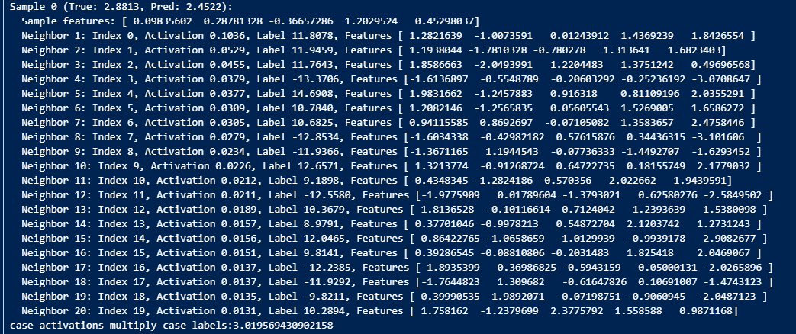
When tau is smaller, the model is more accurate, but it is still doing some kind of interpolation of cases, instead of trying to use the relevant case in terms of y, it is using many cases (each with low activation value), and somehow interpolate the final solution.

when tau = 0.2
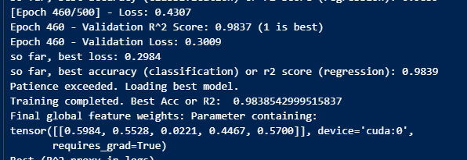
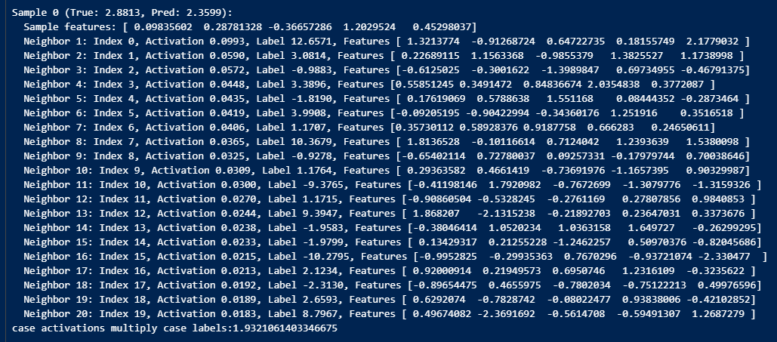

10/17/2025
Regression NNkNN is working. But too many cases are being activated. The nearest neighbor does not have a similar solution as the query’s true solution. It feels like it’s take an average of a little too many cases and each case is only activated by a tiny bit.
10/19, confirmed this: a lot of cases are contributing to the final prediction. About 10-35 cases could be contributing in our simple linear regression problem. Here is a sample output of a query, with its top activated cases:
Sample 4 (True: 6.0492, Pred: 6.0045):
Sample features: [-2.7439084 -1.9040487 0.9187807 0.12344544 2.8273683 ]
Neighbor 1: Index 0, Activation 0.4509, Label 9.7519, Features [ 0.3616786 -1.0170994 0.7204318 -0.10523298 1.8706087 ]
Neighbor 2: Index 1, Activation 0.1306, Label 8.7967, Features [ 0.49674082 -2.3691692 -0.5614708 -0.59491307 1.2687279 ]
Neighbor 3: Index 2, Activation 0.1224, Label 2.5393, Features [-1.2868071 -1.3662828 -0.04625224 -0.61495847 1.2366945 ]
Neighbor 4: Index 3, Activation 0.0356, Label 10.3679, Features [ 1.8136528 -0.10116614 0.7124042 1.2393639 1.5380098 ]
Neighbor 5: Index 4, Activation 0.0267, Label -10.5892, Features [-1.8080289 0.21794334 0.6857624 0.43733805 -1.9561762 ]
Neighbor 6: Index 5, Activation 0.0047, Label 5.6374, Features [ 0.08023621 -0.63169974 -0.74100864 1.8063979 0.9378061 ]
Neighbor 7: Index 6, Activation 0.0040, Label -10.2795, Features [-0.9952825 -0.29935363 0.7670296 -0.93721074 -2.330477 ]
Neighbor 8: Index 7, Activation 0.0034, Label 9.3947, Features [ 1.868207 -2.1315238 -0.21892703 0.23647031 0.3373676 ]
Neighbor 9: Index 8, Activation 0.0020, Label 12.6571, Features [ 1.3213774 -0.91268724 0.64722735 0.18155749 2.1779032 ]
Neighbor 10: Index 9, Activation 0.0017, Label 2.1824, Features [-1.2317393 -1.2463988 -1.4996419 -0.54039687 1.2409896 ]
Neighbor 11: Index 10, Activation 0.0012, Label -7.3255, Features [-1.3284554 1.9493451 0.79958344 -0.01096027 -0.13873476]
Neighbor 12: Index 11, Activation 0.0010, Label 1.1992, Features [-1.2055361 -0.95421034 0.06127657 0.08526105 0.74812526]
Neighbor 13: Index 12, Activation 0.0006, Label 8.9791, Features [ 0.37701046 -0.9978213 0.54872704 2.1203742 1.2731243 ]
Neighbor 14: Index 13, Activation 0.0005, Label -5.7258, Features [-1.5371414 1.0402002 -0.7641999 -0.44291654 -0.00909042]
Neighbor 15: Index 14, Activation 0.0002, Label -3.1180, Features [-1.1588699 -0.71624726 -1.0271013 -1.4785283 0.04580837]
Neighbor 16: Index 15, Activation 0.0002, Label -6.6419, Features [-0.50169003 -0.26296505 0.5634156 -1.1357094 -1.5049162 ]
Neighbor 17: Index 16, Activation 0.0002, Label 4.0558, Features [-0.83794934 -0.45199963 -0.6588856 -0.54960924 1.8101424 ]
Neighbor 18: Index 17, Activation 0.0002, Label -9.3765, Features [-0.41198146 1.7920982 -0.7672699 -1.3079776 -1.3159326 ]
Neighbor 19: Index 18, Activation 0.0001, Label 6.2933, Features [-1.2347237 -0.21592645 0.762771 1.8667208 1.9584366 ]
Neighbor 20: Index 19, Activation 0.0001, Label 9.3778, Features [ 0.9185913 -0.500159 -1.0487858 0.9092391 1.816589 ]
case activations multiply case labels:5.983184857636542

We can see that the activated cases actually have very different labels from the prediction or the true label. Even though their collective prediction (their activation * their label) is very close to the right answer, their own labels are actually pretty far. Somehow the model learned to interpolate an accurate result using widely different cases, instead of most similar cases, like we have seen in classification.

Summary of the Project
How It Works in Practice
Imagine an agent navigating a maze.
- Build the Case Library (The Memory): Every time the agent takes a step (an action a from a state s), it records the outcome: (s, a, reward, next_s). This tuple is just stored in a big list or database.
- Face a New Situation: The agent is now at a new state, s_current. It needs to decide whether to go North, South, East, or West.
- Consult Past Cases: To evaluate going North, it queries its memory:
  - "Find me the k experiences (s', a', ...) where the state s' is most similar to my current state s_current."
  - Similarity is typically measured by Euclidean distance on the state representation (e.g., the raw pixel data or some encoded feature vector). Now we do it with NN-kNN, with feature extractor + euclidean distance (mahalanbois) or cosine distance.
- Estimate the Value: The agent then calculates the Q-value, Q(s_current, North), by taking a weighted average of the outcomes from those k neighbors (use soft attention or softmax-weighted average).
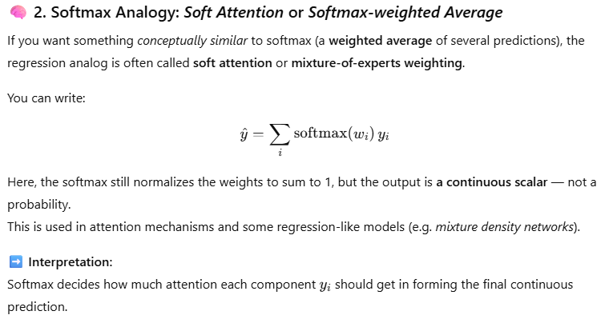
The outcome for a stored experience (s', a', r', s_next') is its immediate reward plus the expected future reward from s_next'. Closer neighbors in the state space get more weight in the average.
- Choose the Best Action: The agent repeats step 3 & 4 for all possible actions (South, East, West) and picks the action with the highest estimated Q-value.
- In this process, feature extractor, similarity measure (feature weights, case weights), case solution (reward r), they are all trainable.
- We may accumulate additional case if it is far away from all existing cases (low similarity)
- We may delete old case if its case weights is lower than a threshold.
Why This is Cool (The Advantages)
This instance-based approach has several major benefits that should resonate with your ML background.
- From the perspective of RL:
- 🧠 Incredible Sample Efficiency: The agent learns immediately. A single new experience is stored and is instantly available to inform the next decision. A deep neural network, by contrast, needs to see thousands of examples and perform many slow gradient updates before a single experience meaningfully changes its behavior. This method can achieve good performance with far less data.
- Online learning
- Can learn feature extraction, distance metric, and RL task all in one go.
- 🔍 Interpretability: This is a huge advantage over deep RL. If the agent makes a strange move, you can inspect the neighbors it used to make its decision. You can literally see its reasoning: "The agent went left here because in these 5 similar past situations, going left led to a high reward." This is impossible with a "black box" neural network.
- Another level of interpretability is in the feature weights. This is especially useful when the feature extractor itself is interpretable, if we are getting interpretable features, then the feature weights in euclidean distance make more sense.
- 🌊 Adaptability: The model easily handles changing environments (non-stationarity). If the rules of the game suddenly change, new experiences reflecting the new rules are simply added to the memory. The agent will naturally start picking neighbors from the new data, without suffering from "catastrophic forgetting" like a neural network might.
- From the perspective of CBR:
- Can also offer CBR adaptation to reuse past cases
- Can offer an integration of CBR + NN, not necessarily just CBR. So a hybrid method. For example: Idea:: we can choose to swap the DQN’s policy net or target net, or both, using NN-kNN. The reasoning is that, we can then have both intuition and memory if we use two kinds of net! For example, if the target net is swapped. It’s as if we are storing cases for long-term use, and policy net make quick decisions to mimick the target net. When we finished training, we can choose to use both nets!

10/4/2025:
It seems that to make NN-kNN work with Q-learning in RL. We need to make NN-kNN a regressor version, instead of its current classifier version. So it will eventually be able to produce a value score for a state-action, by looking at past cases of state-action-rewards and take an average or some kind of adaptations.

Why RL + CBR
We are deviating from the “Full Neural CBR” idea for now. The reasoning is that we have limited resources and time. Full Neural CBR seems easy, but if we do it the easy way, it will only solve simple benchmark datasets, not that exciting. On the other hand, if we do it the hard way, we will likely be tackling some harder tasks that involve domain-specific things. For example, if we are doing a question answering task that require adaptation, we are also dealing with problems on the language side. This could be interesting, if we have more human power and expertise (ML skill in specific domains).
But for now, let’s do game playing, the harder of general AI tasks, that is difficult and do not require domain specific ML skills.
From the point of view of CBR, this is the first time CBR used for reinforcement learning
From the point of view of RL, this is an interpretable AI playing games.

a gudie about sparsemax
Going to try sparsemax and entmax over softmax
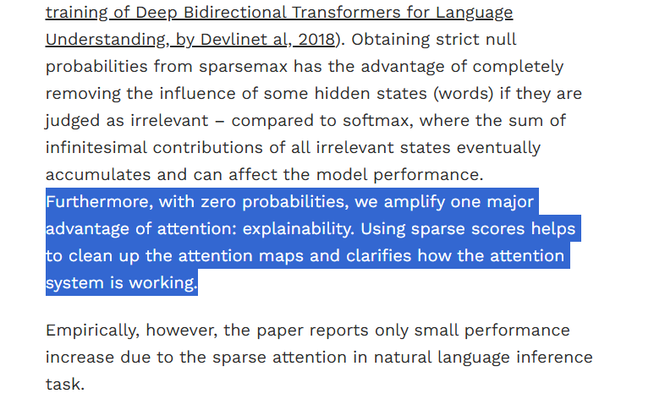

Neural Episodic Control
2017
“Our agent uses a semi-tabular representation of the value function: a buffer of past experience containing slowly changing state representations and rapidly updated estimates of the value function.”
“1. Stochastic gradient descent optimisation requires the use of small learning rates. Due to the global approximation nature of neural networks, high learning rates cause catastrophic interference (McCloskey & Cohen, 1989). Low learning rates mean that experience can only be incorporated into a neural network slowly. ”
We experienced this in our NN-kNN with feature extractors. We found that it is beneficial to have different learning rates for different parts. Specifically, it is nice for the case nets to have large learning weights.
According to the paper, another paper “Using Fast Weights to Attend to the Recent Past” mentioned the same idea.

“
2. Environments with a sparse reward signal can be difficult for a neural network to model as there may be very few instances where the reward is non-zero. This can be viewed as a form of class imbalance where low-reward samples outnumber high-reward samples by an unknown number. Consequently, the neural network disproportionately underperforms at predicting larger rewards, making it difficult for an agent to take the most rewarding actions.
3. Reward signal propagation by value-bootstrapping techniques, such as Q-learning, results in reward information being propagated one step at a time through the history of previous interactions with the environment. This can be fairly efficient if updates happen in reverse order in which the transitions occur. However, in order to train on uncorrelated minibatches DQN-style, algorithms train on randomly selected transitions, and, in order to further stabilise training, require the use of a slowly updating target network further slowing down reward propagation.”

“In this paper we propose Neural Episodic Control (NEC), a method which tackles the limitations of deep reinforcement learning listed above and demonstrates dramatic improvements on the speed of learning for a wide range of environments. Critically, our agent is able to rapidly latch onto highly successful strategies as soon as they are experienced, instead of waiting for many steps of optimisation (e.g., stochastic gradient descent) as is the case with DQN (Mnih et al., 2015) and A3C (Mnih et al., 2016).”

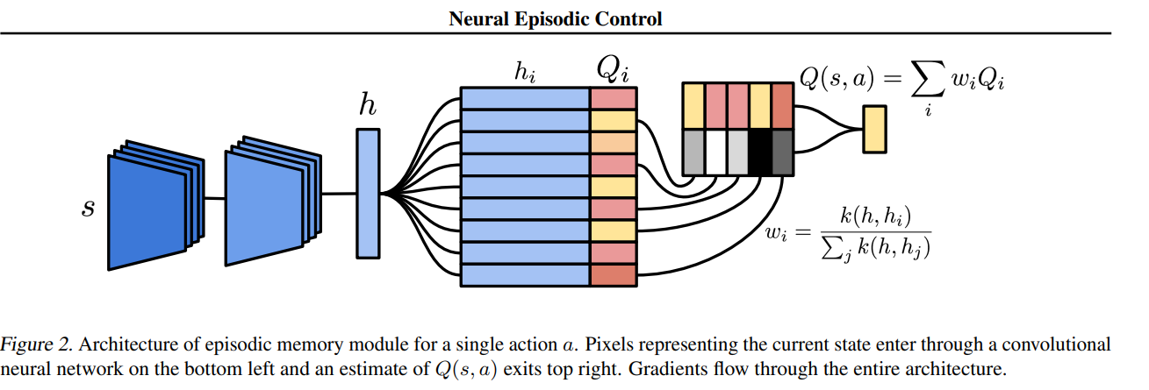
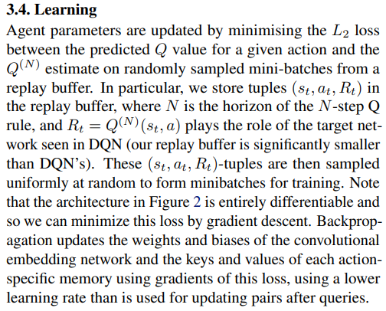
So what really stands this out, form the model-free episodic control is that, it has two learning component, the knowledge accumulation (online learning, discussed in section 3.3) and the learning/knowledge distillation (offline learning discussed in section 3.4).
We could do the same thing, because we are also an end-to-end differentiable model with a case base.

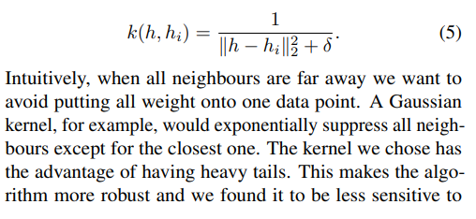
Interesting choice of kernel, distance function

“In contrast with the ideas presented here, none of the localregression work aforementioned uses the reward signal to learn an embedding space of covariates in which to perform the local-regression. We learn this embedding space using temporal-difference learning; a crucial difference, as we showed in the experimental comparison to MFEC. ”
We are doing the same thing in NN-kNN
One additional benefit, if the feature extractor is interpretable, we can make the whole RL process interpretable! This is doable for simple tasks such as cart-pole where feature extractor can be very interpretable. Could work for bigger tasks too.
“Our work suggests that non-parametric methods are a promising addition to the deep reinforcement learning toolbox, especially where data efficiency is paramount. In our experiments we saw that at the beginning of learning NEC outperforms other agents in terms of learning speed. We saw that later in learning Prioritised Replay has higher performance than NEC. We leave it to future work to further improve NEC so that its long term final performance is significantly superior to parametric agents. ”
Idea:: we can choose to do policy net or target net, or both, using NN-kNN. The reasoning is that, we can then have both intuition and memory if we use two kinds of net!

Model-Free Episodic Control
2016
From google deepmind
Can be very relevant!
“ Here we investigate whether a simple model of hippocampal episodic control can learn to solve difficult sequential decisionmaking tasks. We demonstrate that it not only attains a highly rewarding strategy significantly faster than state-of-the-art deep reinforcement learning algorithms, but also achieves a higher overall reward on some of the more challenging domains”
Faster training, higher performance in RL.
“Tabular RL methods suffer from two key deficiencies: firstly, for large problems they consume a large amount of memory, and secondly, they lack a way to generalise across similar states. To address the first problem, we limit the size of the table by removing the least recently updated entry once a maximum size has been reached. Such forgetting of older, less frequently accessed memories also occurs in the brain [8].”
“In large scale RL problems (such as real life) novel states are common; the real world, in general, also has this property. We address the problem of what to do in novel states and how to generalise values across common experiences by taking QEC to be a non-parametric nearest-neighbours model.”
In section 3. they talk about how different ways for feature extraction can influence the similarity metric and similarity in knn. They didn’t offer a good solution, other than saying that we need to compress the dimension, extract relevant features. They used VAE, and they acknowledged that distance metric can be learnt too.
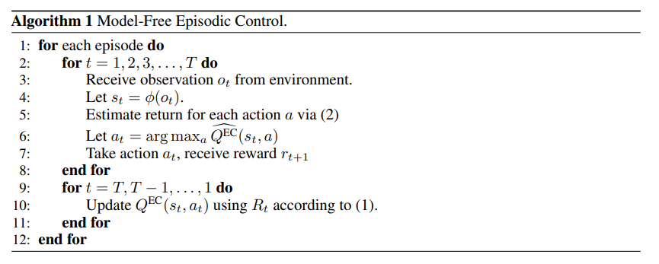
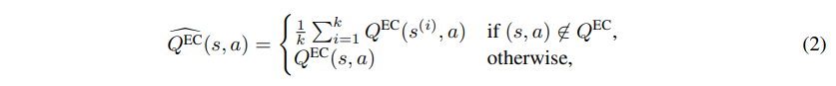
They applied their work in Atari and Labyrinth walking

LEARNING TO REMEMBER RARE EVENTS
2017
“We present a large-scale life-long memory module for use in deep learning. The module exploits fast nearest-neighbor algorithms for efficiency and thus scales to large memory sizes. Except for the nearest-neighbor query, the module is fully differentiable and trained end-to-end with no extra supervision. It operates in a life-long manner, i.e., without the need to reset it during training.”
“We present a life-long memory module that enables one-shot learning in a variety of neural networks. Our memory module consists of key-value pairs. Keys are activations of a chosen layer of a neural network, and values are the ground-truth targets for the given example. This way, as the network is trained, its memory increases and becomes more useful. Eventually it can give predictions that leverage on knowledge from past data with similar activations. Given a new example, the network writes it to memory and is able to use it afterwards, even if the example was presented just once. ”
Very similar in terms of retrieval, they are using activation of a layer as the key (problem description in cbr). They are using cosine distance. The similarity metric cannot be trained, yet they train the key of cases. They also have a “age” attribute associated with each case. They also use matrix multiplication to speed up k-nn calculation.
“The memory module presented above can be added to any classification network. There are two main choices: which layer to use to generate queries, and how to use the output of the module.”
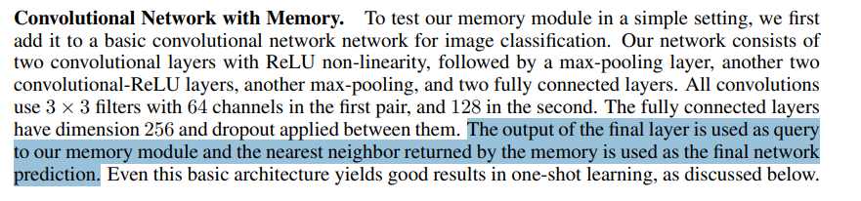
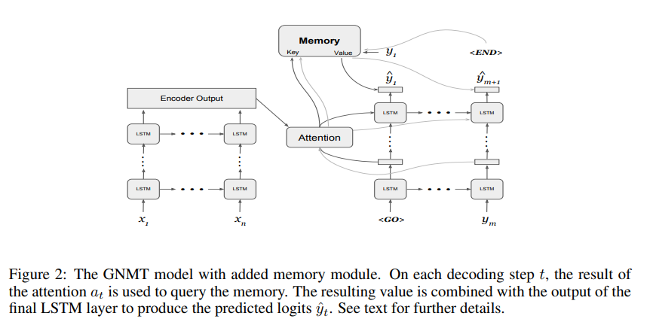

Summary: What they did was a retrieval mechanism, using cosine distance, trained by updating keys. The values are then used either for final classification, or as a feature/embedding for downstream tasks. They showed different tasks, including a one-shot learning, and online learning setting. Very similar in spirit to NN-kNN (when we use it for image/language).

Improving Reinforcement Learning by using Case Based Heuristics
It seems they are using CBR to speed up the RL training, not necessarily changing the RL.
Case Based Heuristically Accelerated Q–Learning (CB-HAQL), which allows the use of a case base to define heuristics to speed up the well-known Reinforcement Learning algorithm Q–Learning. This approach builds upon an emerging technique, the Heuristic Accelerated Reinforcement
Learning (HARL), in which RL methods are accelerated by making use of heuristic
information
Essentially, they are forcing the reward to match with the knowledge from a CBR case base.

Instance-based Generalization in Reinforcement Learning
Neurips 2020
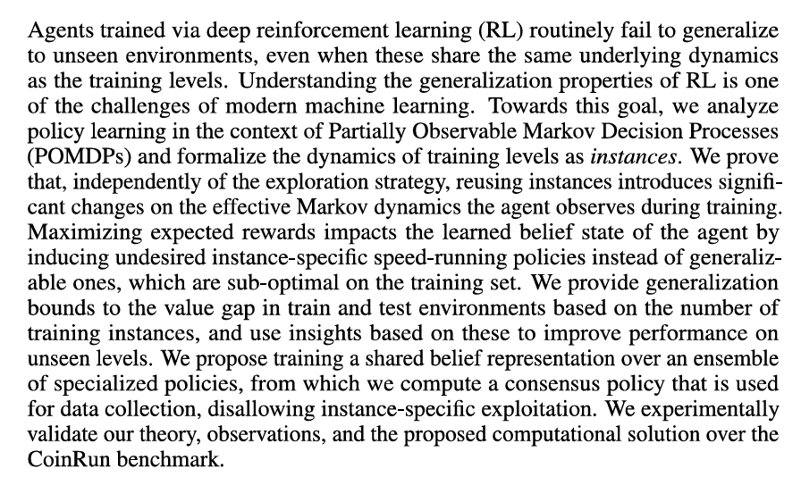
Coin run, this can be one of our test bench
https://openai.com/index/quantifying-generalization-in-reinforcement-learning/
A very good benchmark for generalized RL
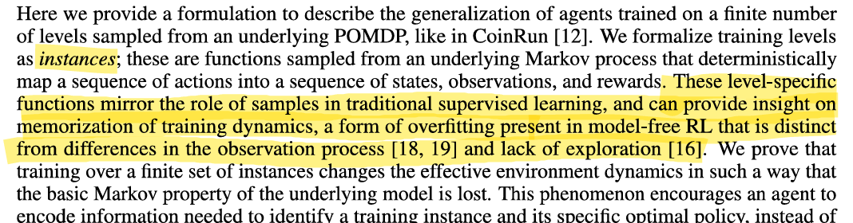

Explanation from Gemini about this paper
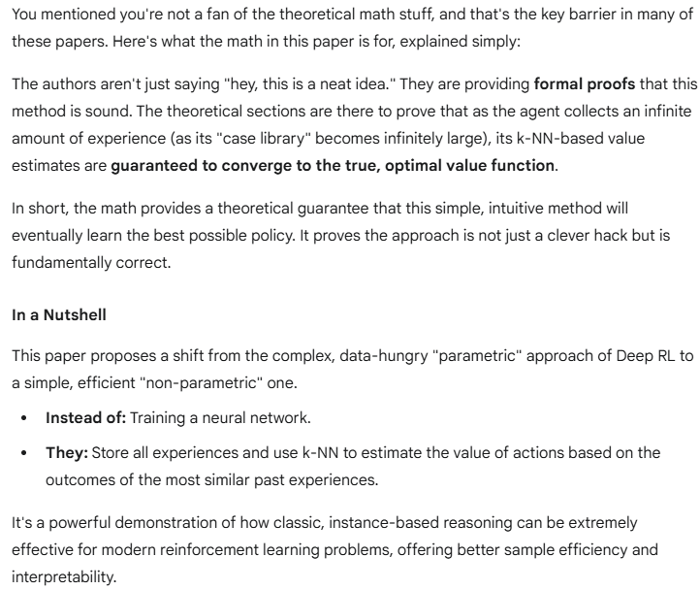

MartinBertran/InstanceAgnosticPolicyEnsembles
Their code

Seems very theoretical and too mathy. Not directly relevant

OpenAI Gym
Gymnasium Documentation

Deep Q Learning over Q-Learning
Reinforcement Learning (DQN) Tutorial — PyTorch Tutorials 2.8.0+cu128 documentation
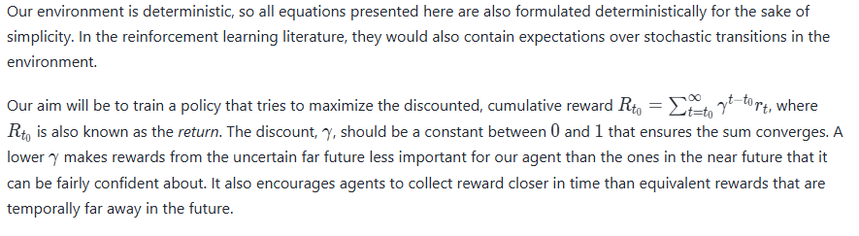
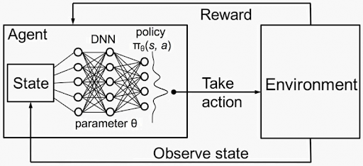
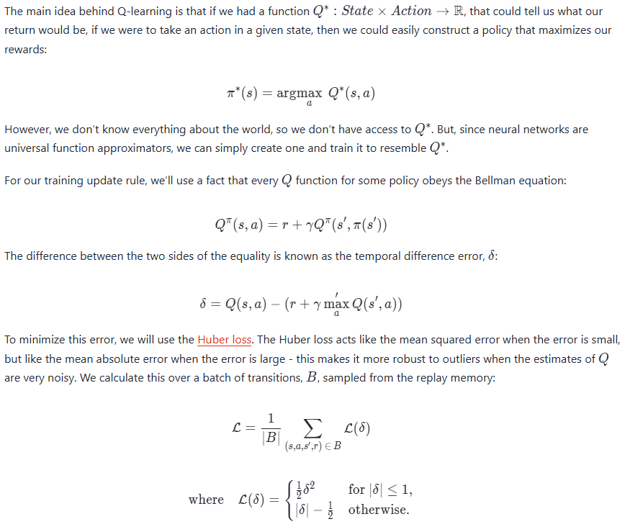
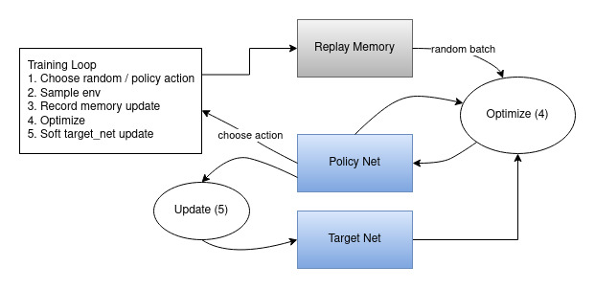
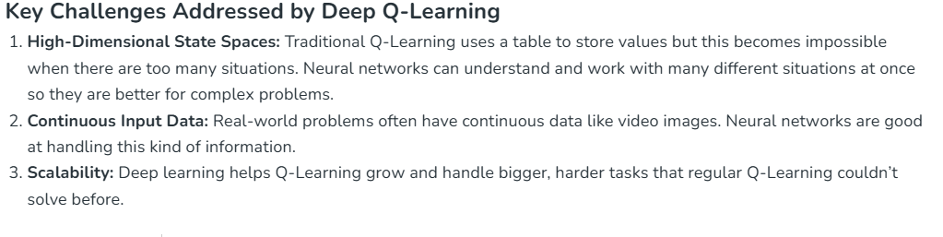
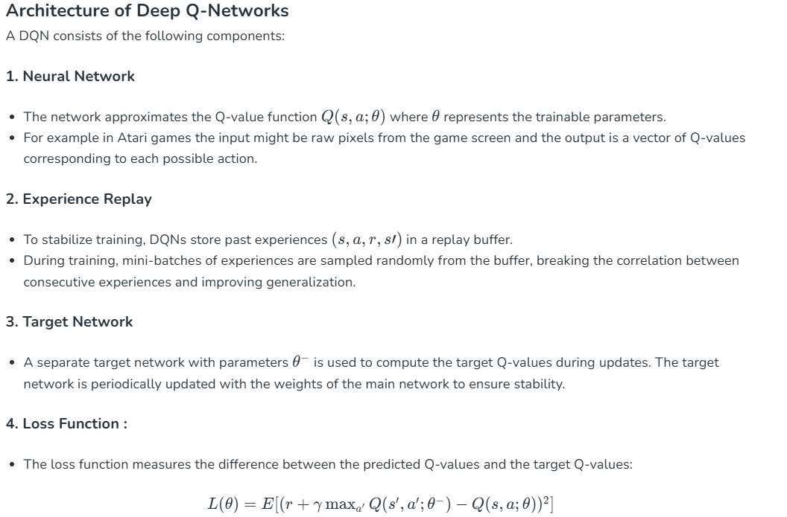
The same is true for NN-kNN. As NN-kNN is a neural method, we can easily say NN-kNN has the same advantage here and can be swap in here as the neural network.

Gym for Connect 4
GitHub - lucasBertola/Connect-4-Gym-env-Reinforcement-learning: Connect Four Environment is a project designed for training reinforcement learning models to play the classic Connect4 game. It's compatible with OpenAI Gym / Gymnasium, includes a variety of bots, an Elo leaderboard system, and supports both FCN and CNN policies.

Q-learning with Nearest Neighbors
Neurips paper from MIT
Theoretical, not that useful for us.
The Shah & Xie (2018) “Q-learning with Nearest Neighbors” paper is primarily a theoretical reinforcement learning paper:
- ✅ Focus:
They ask — if we replace function approximation with nearest-neighbor regression in Q-learning, can we prove convergence in continuous state spaces?
- ✅ Main contribution:
  - Formal algorithm definition (NNQL).
  - Finite-sample guarantees — how the error decreases as you collect more samples.
  - Sample complexity bound: about O~(ϵ−(d+2))\tilde O(\epsilon^{-(d+2)})O~(ϵ−(d+2)).
  - They show this matches known lower bounds, meaning their method is nearly optimal in theory.
- ❌ What’s missing:
  - They don’t run large-scale RL experiments (like CartPole or Atari).
  - No practical neural implementations.
  - The figures are mostly conceptual — the heavy lifting is in probability bounds, covering numbers, Lipschitz continuity, etc.

Medium Example, RL AI playing catch
https://medium.com/@www.seymour/training-an-ai-to-play-a-game-using-deep-reinforcement-learning-b63534cfdecd
RL Training an AI to play catch a falling brick.

Policy Reuse in RL
- Case-Based Policy Reuse (CBPR) (Fernández & Veloso, 2006):
They used a CBR system to retrieve entire past policies for similar tasks, so an agent could quickly adapt in new but related RL problems.
https://www.cs.cmu.edu/~mmv/papers/06aamas-policy-reuse.pdf
- “Our method relies on using the past policies as a probabilistic bias where the learning agent faces three choices: the exploitation of the ongoing learned policy, the exploration of random unexplored actions, and the exploitation of past policies. ”
- “In summary, Policy Reuse contributes to the overall goal of a lifelong reinforcement learning agent, as (i) it provides a mechanism to reuse past policies; (ii) it incrementally builds a policy library; and (iii) it learns an abstract domain structure in terms of core policies of the domain.”
- Key difference, they are reusing policy, not reusing steps/episodes in a memory. They measure the similarity between policies by measuring the gain of the old policy in the new task

Frozen-lake example
Part 5— Implementing an Iterable Q-Table in Python | by Priyam basu | Hashtag by IECSE | Medium

